-------------------
Business Improvement Areas: Online Map Shows Calgary’s Business Improvement Areas (BIA)
Did you know that Calgary has 15 Business Improvement Areas (BIA)? A BIA is a group of businesses, within a defined geographic area, that work together on local improvements. Established under the Municipal Government Act of Alberta, BIAs are funded by an annual levy which is collected from the area’s businesses by The City and transferred to the BIA board of directors as stipulated in the regulation. An interactive map and dashboard are available which provides information on where Calgary’s BIAs are located, as well as demographic information, such as household lifestyle, income, people and businesses within the BIA. To view this map, visit https://maps.calgary.ca/BIA/. To view more City of Calgary maps, please visit the Map Gallery at https://maps.calgary.ca .
------------
Green Line LRT update
As the largest infrastructure investment in Calgary’s history, with $5.5B in unprecedented contributions from all three levels of government, the Green Line LRT will shape mobility for generations.
Phase 1 of Green Line, from Shepard to Eau Claire, will connect the Southeast to Downtown and into the existing Red and Blue lines and four MAX BRT routes building 13 stations, 18 km of LRT track and three park and ride facilities.
This phase alone delivers almost 20,000 new direct and supporting jobs, provides new LRT access to Calgarians through more than 50,000 daily boardings and removes 26,750 GHGs annually. The economic impact of this investment will directly benefit local contractors, trades and suppliers while delivering over $2.2B in long-term city-shaping benefits.
When people ask “when is Green Line construction starting”, the answer is that it has. Constructing mega projects, like Green Line, starts with early works construction to make way for the main infrastructure.
Phase 1 early work includes over $300 million in utility, road, sidewalk, pathway and other infrastructure upgrades and projects such as remediation of two landfill sites and a tunnel under existing railway tracks. Early works in the southeast are complete with the focus now on the Beltline and Downtown.
The Green Line is a long-term investment in Calgary's future and as our city grows, we will make sure we all can live, work and play in sustainable and affordable ways. For more information and to sign-up for updates, visit calgary.ca/greenline.
----------------
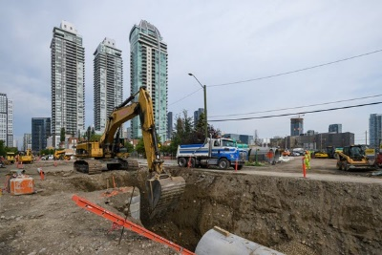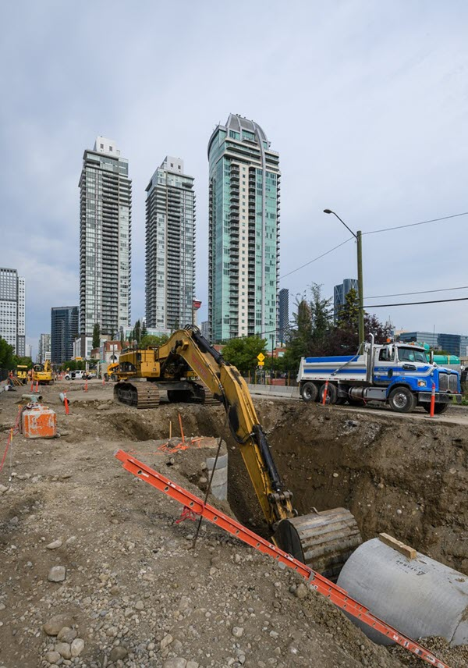
Images courtesy of City of Calgary

