Staying Safe Around Calgary’s Waterways: Ice Safety

Student Workbook

Calgary Fire Department

Introduction:
This Ice Safety workbook is designed to be a helpful review of the safety messages presented in the Staying Safety Around Calgary’s Waterways presentation. Completing it will become your reference guide to help you remember the important water safety messages.

Acknowledging the Land:
Indigenous People have gathered at the confluence of the and rivers for many generations before The City of Calgary was incorporated by settlers in 1884. A confluence is when two streams or rivers flow together and also symbolically refers to bringing people together. This is an important waterway feature that continues to bring people together to form the community where we live.

2 Basic categories of bodies of water
- water in rivers
- water in lakes

Water temperature:
Cold water is any water colder than ºC
At ºC water changes physical states from a liquid to a solid called . Ice has a density than liquid water so the ice will ontop of water.
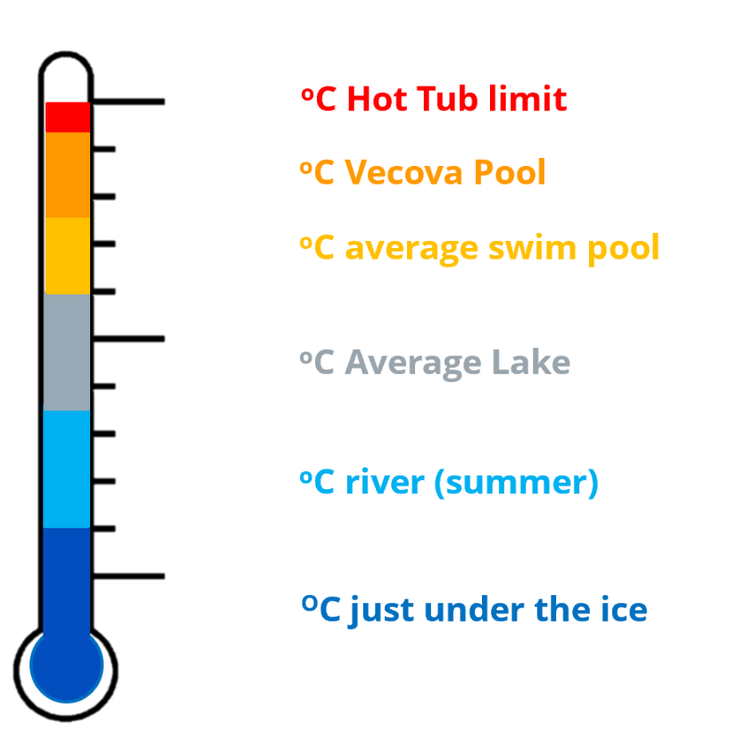

Ice Safety Quiz
Question | TRUE/YES | FALSE/NO
Thick ice is strong
If the air is very cold, then the ice is strong
Snow on top of ice makes ice weaker and freeze slower

Storm ponds
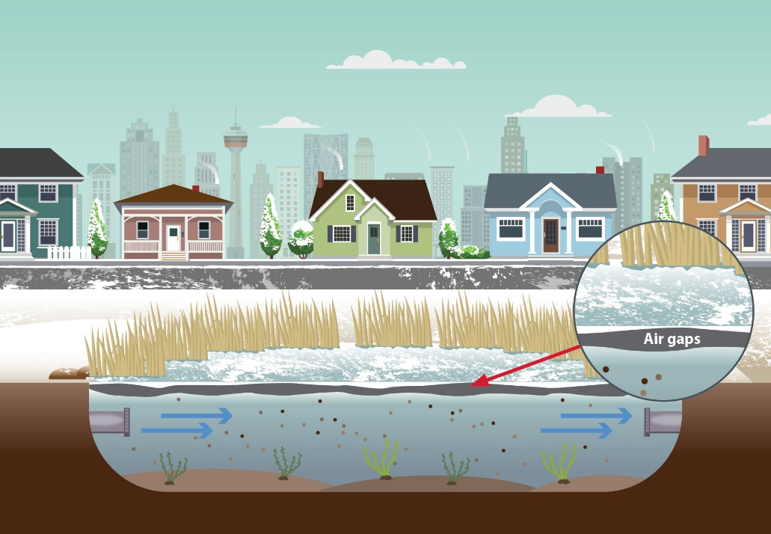

Match the storm pond hazard with the explanation (add letters to illustration)
Air gaps, empty spaces between the ice and water, are caused by changing water levels.
Sediment and contaminants that are collected as water travels through the community on the way to the storm pond weaken the ice.
Water is constantly moving in and out of the pond through pipes. This can result in strong currents that can trap you under the ice if you fall through.
A

B

C

Draw a line to match the hazard symbol with the correct meaning
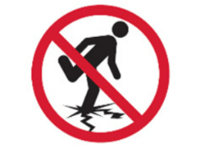
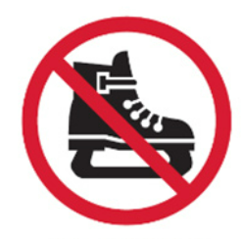
No pets
No tobogganing
No skating
No fishing
No walking on the ice

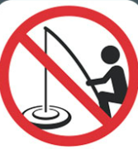
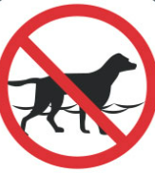
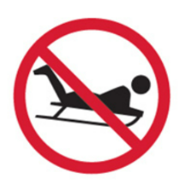

Water Rescue Steps

*ALWAYS Keep yourself safe*
TALK | TURN AROUND  LIE FLAT  KICK YOUR LEGS  CRAWL onto the ice  KEEP KICKING  ROLL away
CALL 9-1-1 | Look for LANDMARKS

*THROW

*REACH

STOP/STAY BACK

For More Information
www.calgary.ca/fire
Follow us on Facebook or Subscribe to the City of Calgary YouTube channel

