-------------------
Where to Park: Online Map Shows Calgary’s Residential Parking Zones
When planning a trip within the city, don’t forget there are many residential areas in Calgary that have parking restrictions. The Calgary Residential Parking Zones map shows communities which have residential parking zones established to help communities control the number of non-resident vehicles parked there. To ensure you are parking in residential areas where permits are not needed, visit the map at https://maps.calgary.ca/CalgaryParking/.
To view more City of Calgary maps, please visit the Map Gallery at https://maps.calgary.ca/.
------------
We’re updating how we advertise public hearings
Planning & Development Services is introducing a new bylaw to modernize how we advertise public hearings of City Council on planning matters. Public hearing notices are now fully detailed on our updated webpage.
Our transition will be gradual. Newspaper ads will continue until June 2023, while we use other methods like social media, web ads and community newsletters to help inform the public of the changes.
Having the public’s participation in planning matters is an important part how we build Calgary. Modernizing our advertising methods will more effectively reach larger numbers of citizens on planning applications going to Council. As well, we’ve increased our efforts to connect citizens who have limited English language skills by creating language-specific ads.
Visit calgary.ca/planningmatters for more details or contact approvals@calgary.ca with your questions.
----------------
The City of Calgary is home to more than 8,500 hectares of parkland and natural areas, as well as 1,000 km of pathways. Park space is available for all Calgarians to enjoy. Modifying or building onto the land beyond property lines disrupts the delicate environmental balance in natural areas, creates safety issues and interferes with all citizens’ ability to enjoy these spaces. Encroachments onto park space are regulated under Encroachment Bylaw 9M2020.
An encroachment is when any kind of structure, landscaping or other improvement extends from a homeowner’s property onto City-owned property. An encroachment also includes mowing behind a property line, constructing fire pits, planting non-native vegetation, placing compost bins and building forts or bike jumps within these natural areas.
The creation of bike jumps in natural areas have the potential to increase soil erosion, create unstable and dangerous terrain conditions, damage native vegetation, risk spreading invasive species, disrupt wildlife habitat and unearth and damage archeological artefacts. In order to keep our natural areas healthy, Calgary Parks is restoring damaged habitat in natural environment parks located in Mckenzie and Chaparral. This work will involve dismantling bike jumps and wooden structures, decompaction of soil, digging out and spreading mounded soil, and re-seeding bare soil with native grasses and wildflowers. These areas will be closed to allow the vegetation to grow, please respect these closures.
The City of Calgary is committed to working with homeowners to ensure that identified structures, objects or landscaping encroachments are removed and the park space is returned to its original intended use. For more information on encroachment, please visit calgary.ca/encroachmentparks or contact 311.
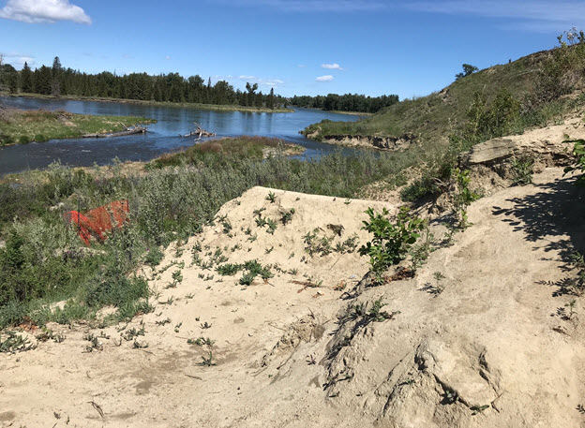

Image courtesy of City of Calgary
------------

