Our Building’s New Recycling Program
[Date]
We are excited to announce our building’s new recycling program. This letter is to let you know about our building’s new recycling program. Starting on [date], we will be accepting recycling.
Who is collecting our material?
[If you are taking the material to a Community Recycling Depot or recycling facility yourself, please include:]
[Name] will collect our material regularly and will take it to be recycled.
[If you have hired a private recycler, please include:]
[Company] has been hired to collect our material.
Where are the recycling containers?
The recycling area will be located in _________________________. You should [place all your material in the same bin/sort your material according to the signs/other.]
How do I prepare my material?
[If you are taking the material to a Community Recycling Depot yourself, please include:]
- Keep your material loose, not in bags, except:
  - Shredded paper, which should be tied in a clear plastic bag
  - Plastic bags and plastic wrap, which should be placed together in a bag
- Rinse jars and cans to remove any food residue
- Flatten your cardboard boxes to save space
[If you have hired a private recycler, please discuss this section with them, as rules and preparation may vary. This area could include information about separating lids from jars and bottles, whether or not to put material in bags, and whether the material needs to be sorted.]

What can I recycle?
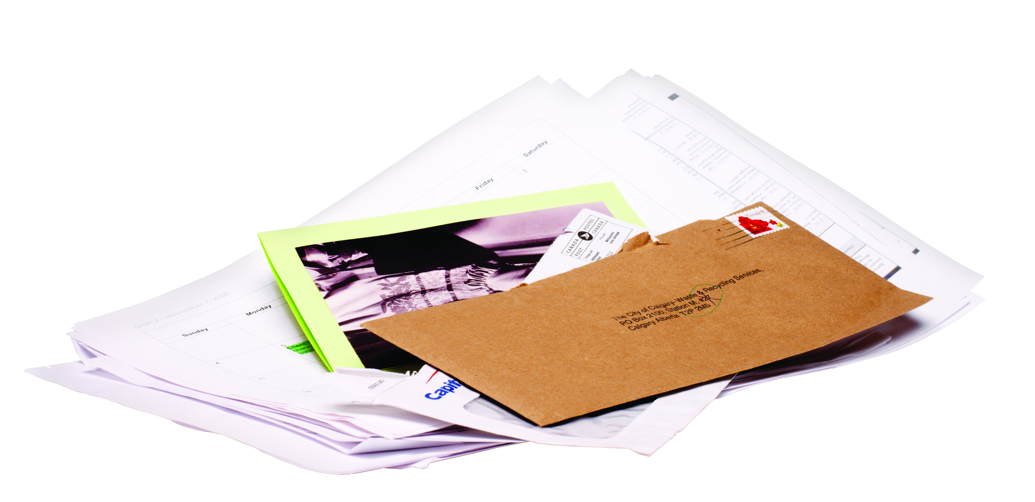 | Paper: Newspaper, catalogues and magazines, mixed paper, shredded paper, telephone books |  | Refundable beverage containers
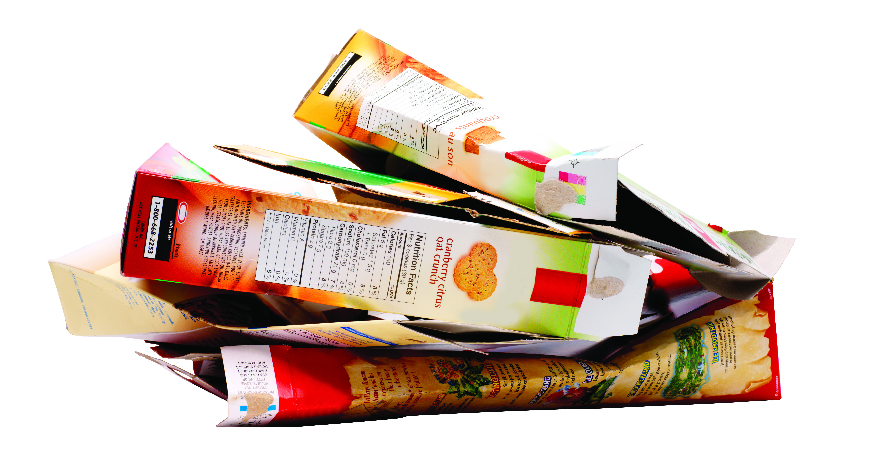 | Boxboard and corrugated cardboard |  | Plastic containers with the recycling symbols 1-7, except polystyrene foam
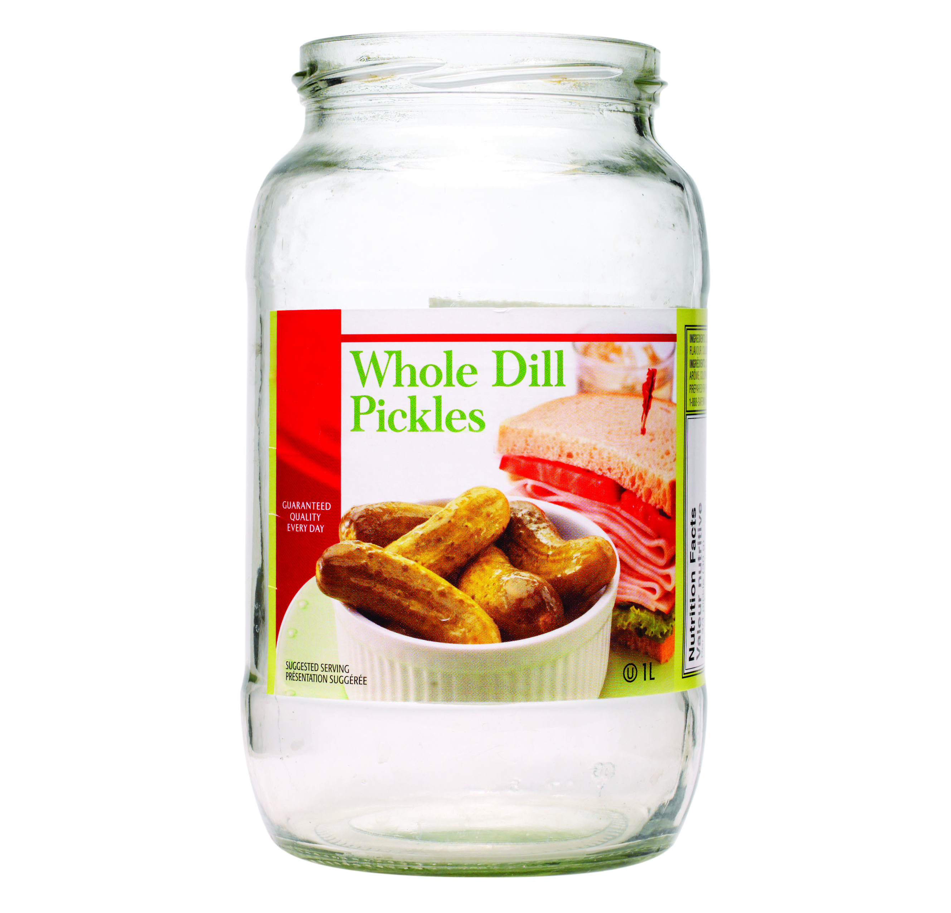 | Glass jars and bottles | 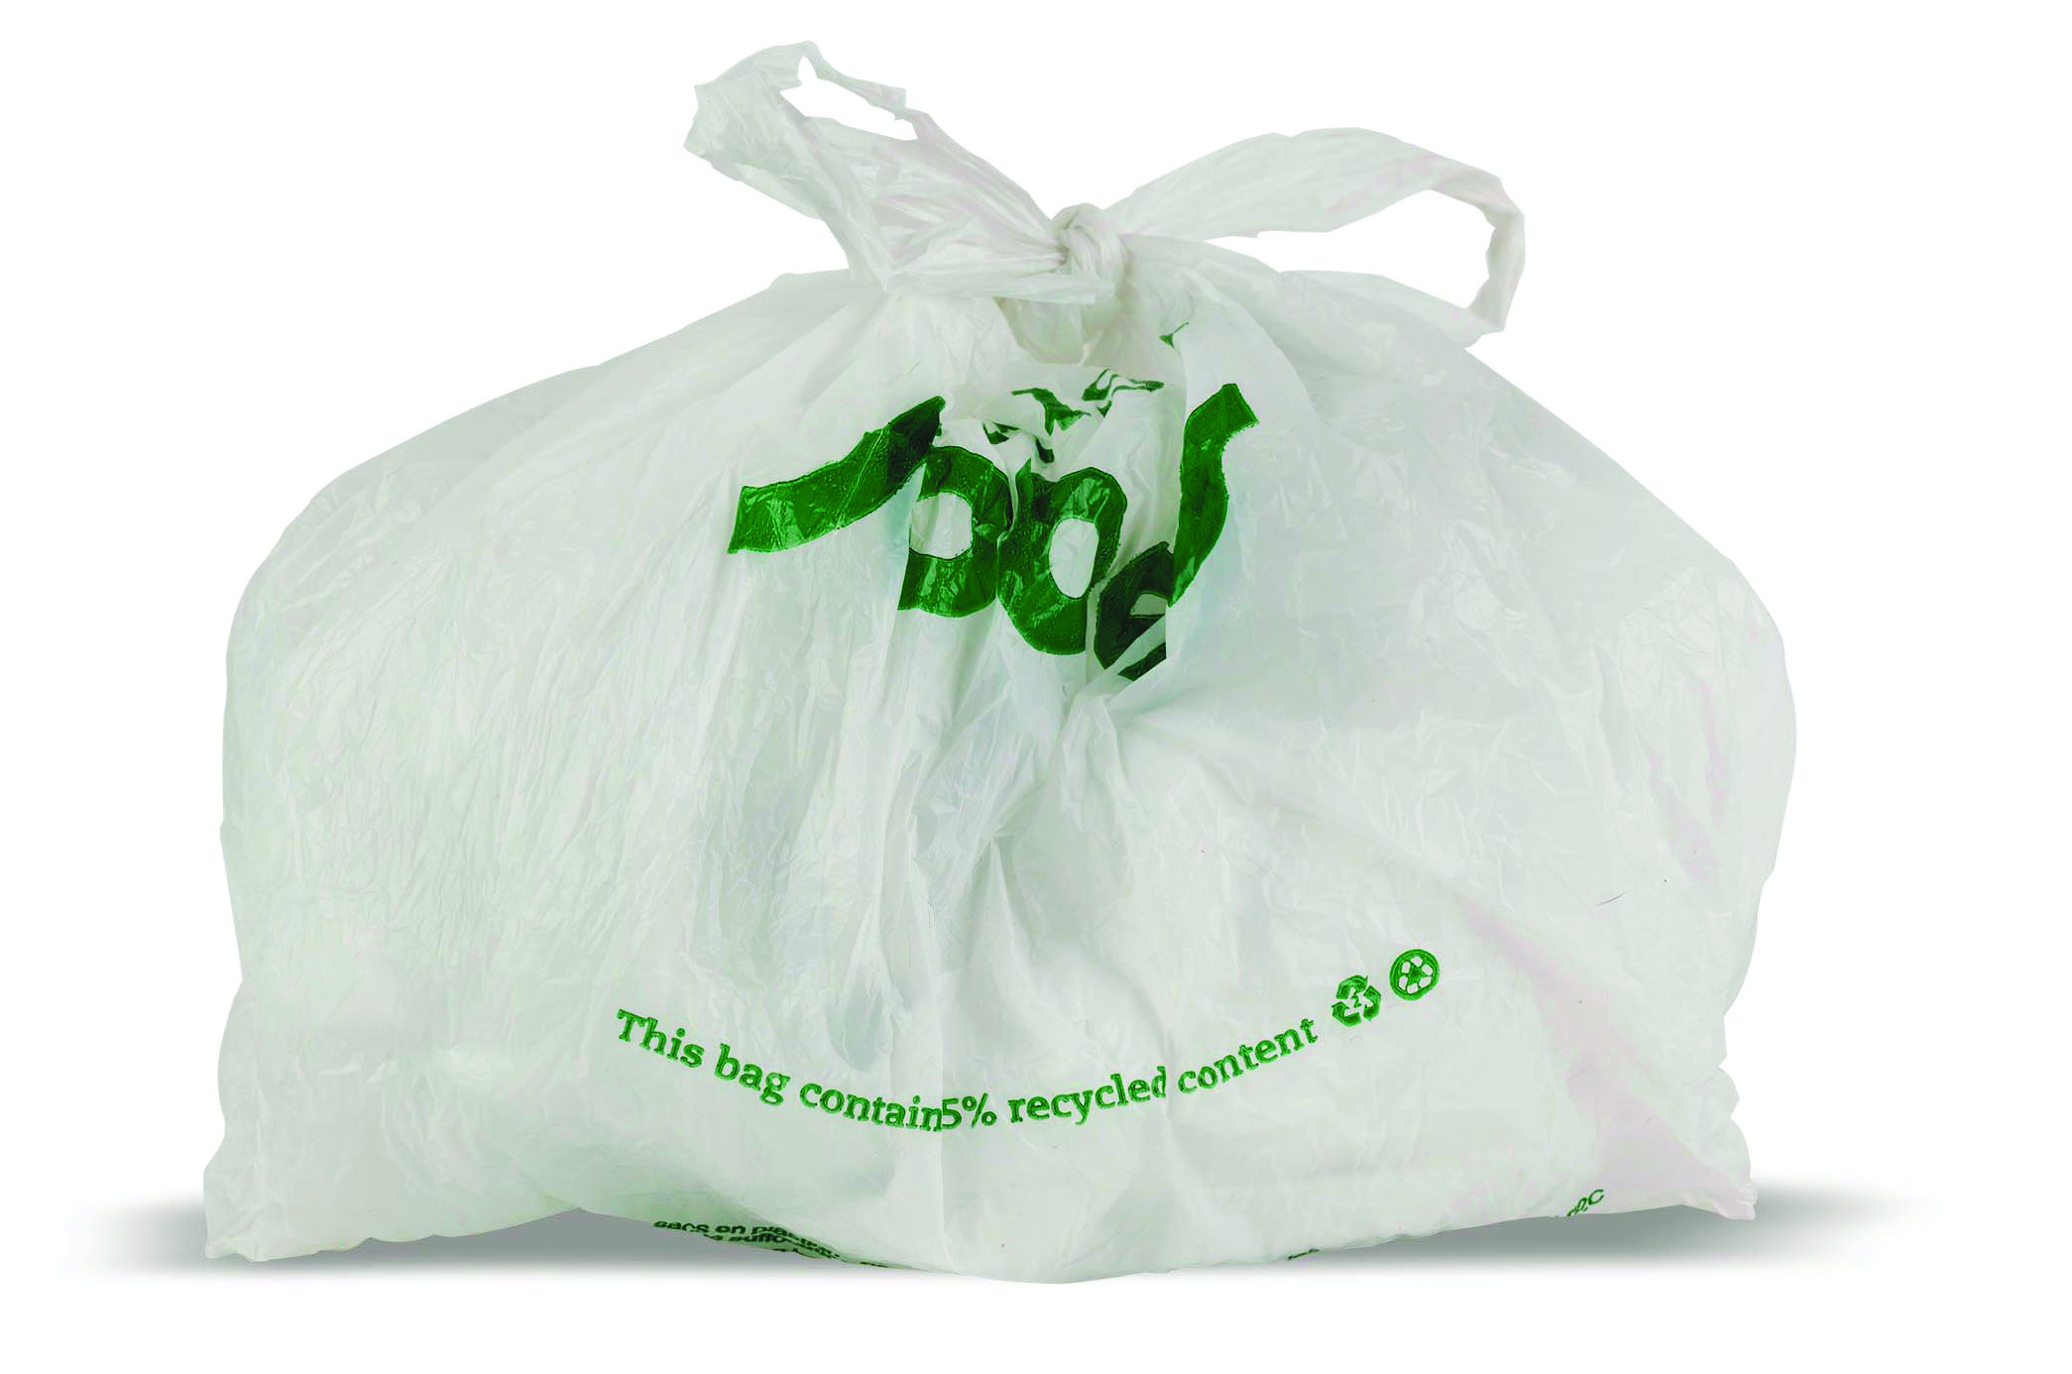 | Plastic bags
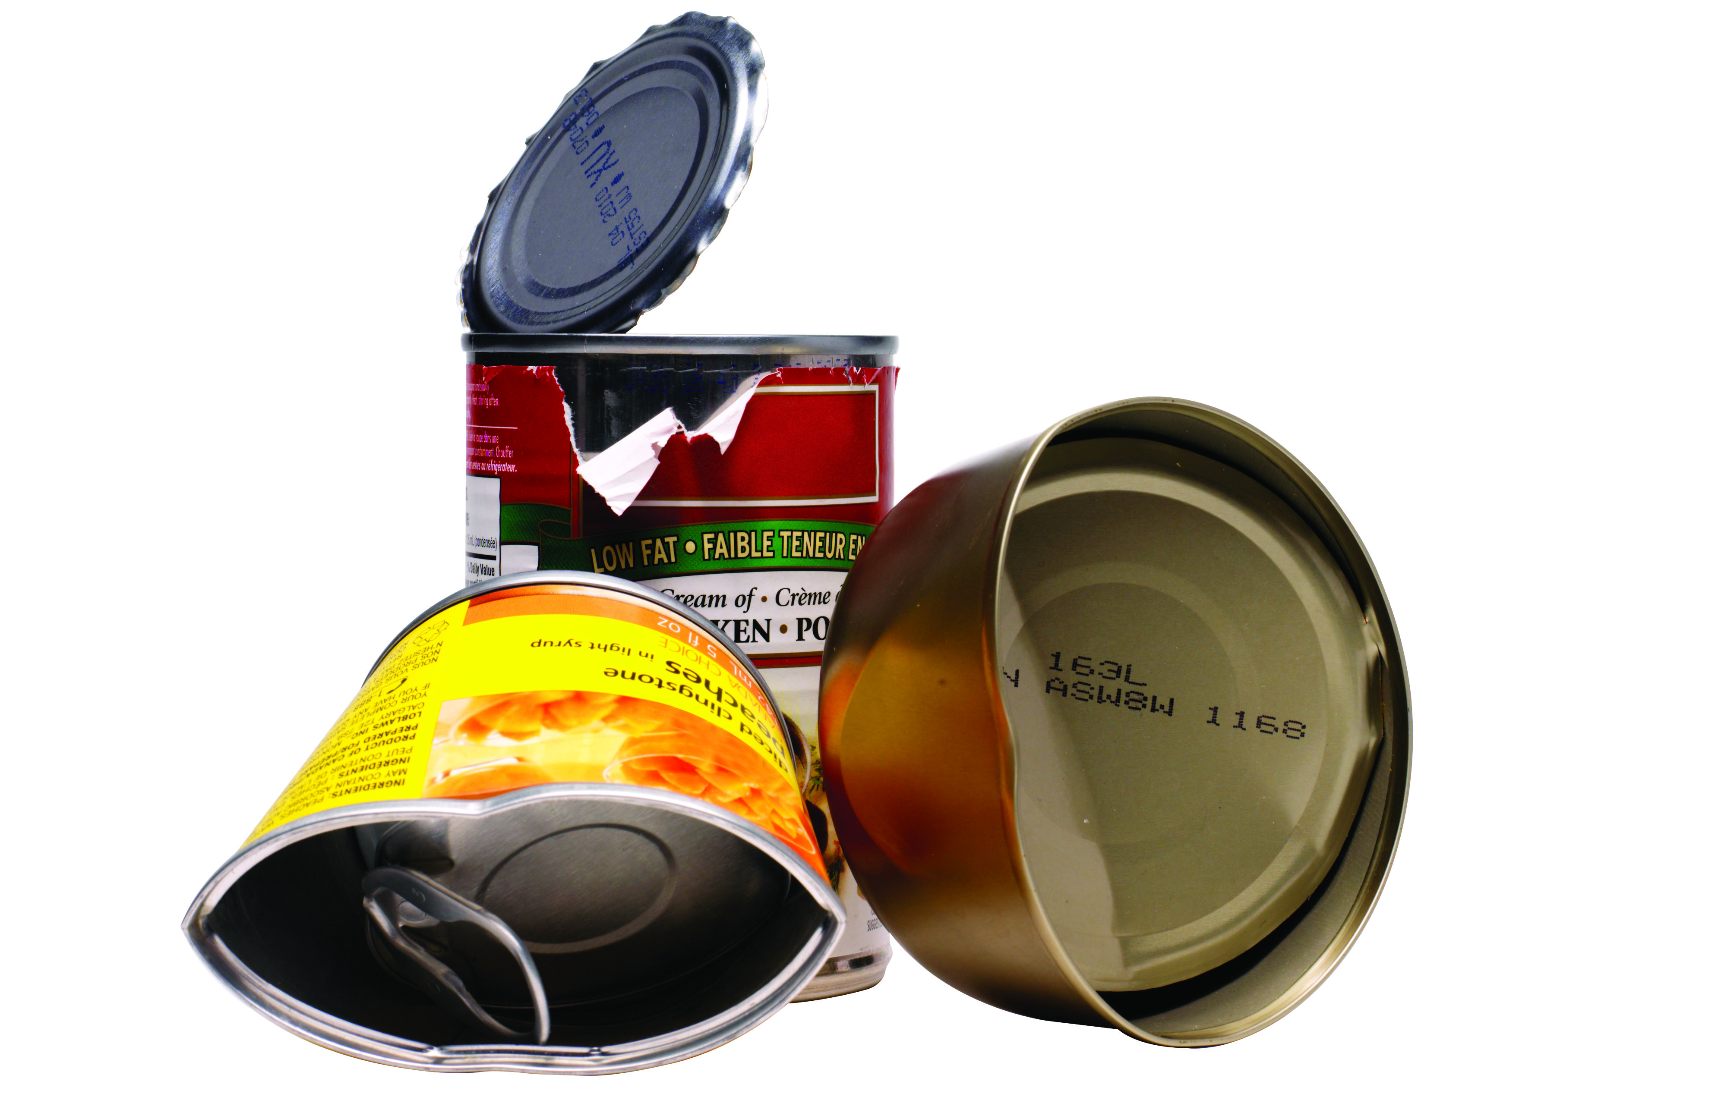 | Food cans and foil |  | Juice boxes and soup boxes (such as TetraPaks™)
[others, if applicable]
This is an easy way we can all make a difference. By recycling we can reduce our garbage by almost 25 per cent.
If you have any questions, please contact [contact name, number or email].
Sincerely,

